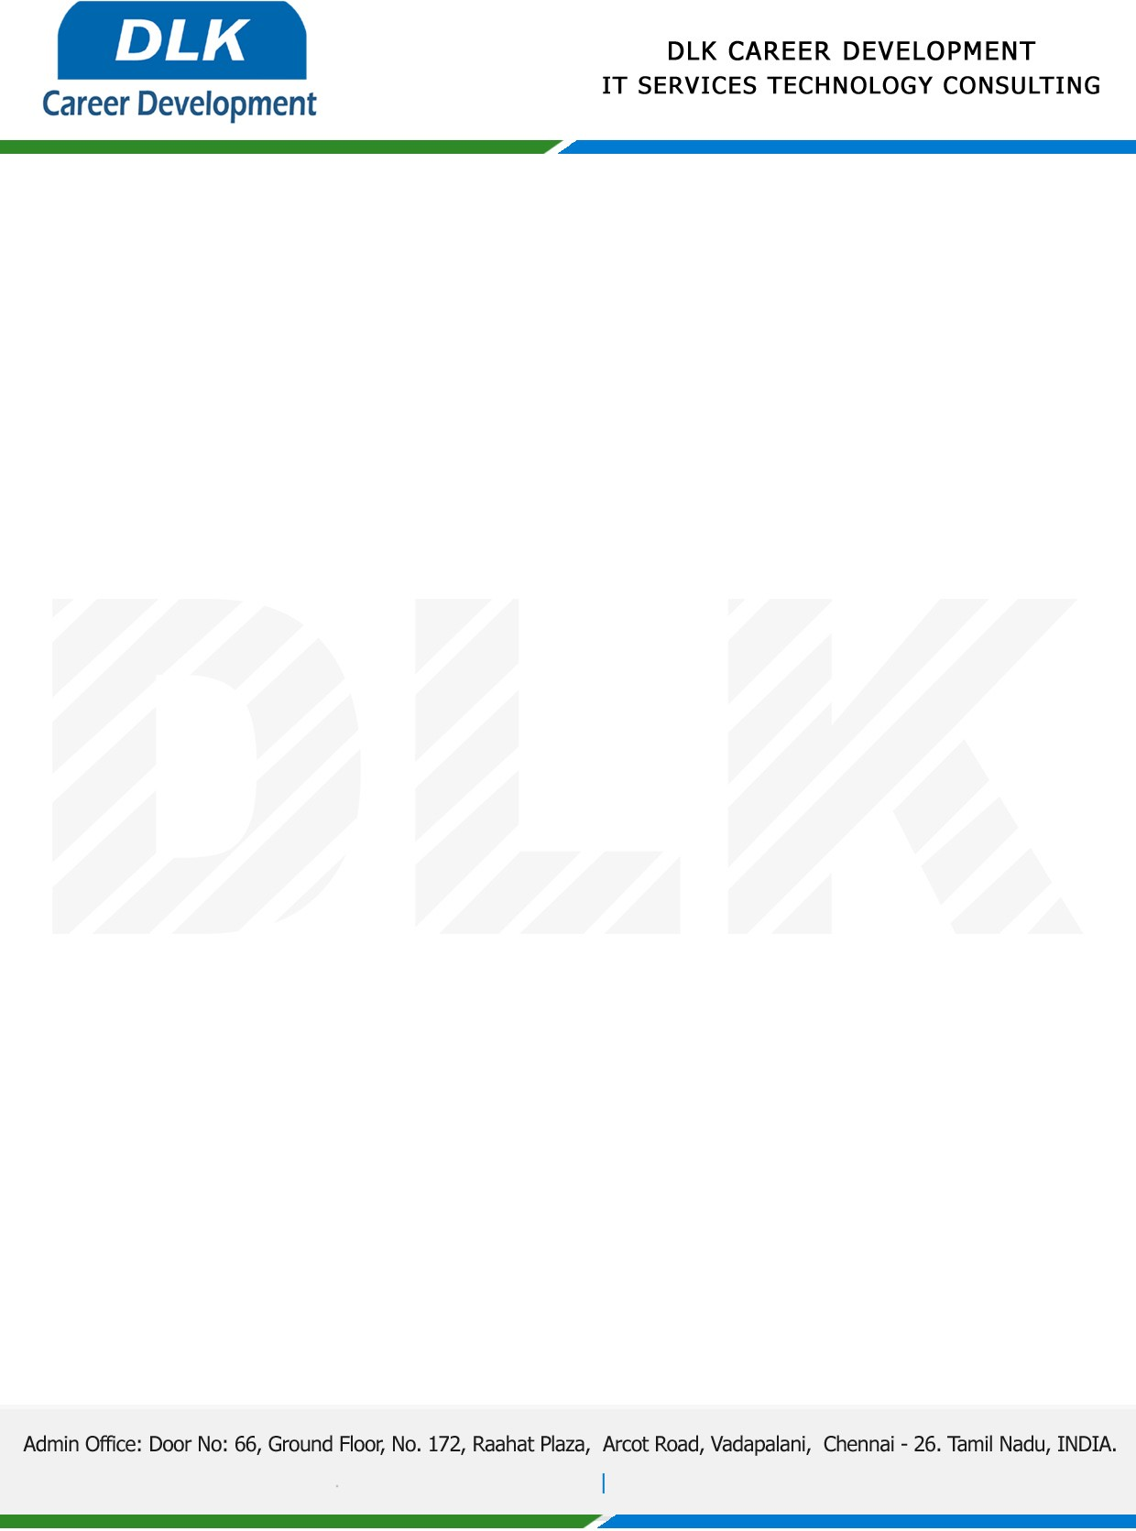

Date: 31 / December/ 2022

**To**

Department of MBA ( [Human Resource),](https://www.cseindia.org/)

Head of Department,

St. Peter's lnstitute of Higher Education and Research Avadi, Chennai- 600077.

**Sub: Letter of Project Acceptance**

This is to certify that **MR DEENADAYALAN S (REG NO: SP21BAP007)** Final year student of has accepted the Project Work duration from **02nd January 2023 to 31st March 2023** under the domain **“Human Resource”.** During the Project, all information and data collected from you should be kept confidential.

**Topic:** A Study on Training and Development.

We appreciate your interest in **DLK CAREER DEVELOPMENT**

